Clustering and Fitting of World Bank Climate Indicators

Name: Minhajur Rahman
ID - 24150182
Module: 4PAM2000 Data Science Lab 1
GitHub repository: https://github.com/minhaj25-ux/assignment3-clustering-fitting

Abstract
This analysis works with a compact dataset sourced via the World Bank, comparing nations through three lenses: carbon output per individual, economic output per capita, and reliance on green energy sources. Following that, countries get sorted into distinct clusters during phase one. Then comes modeling - specifically, a basic structure built around China’s per-person emissions trend helps sketch what might come next. What stands out? Poorer nations in the set show markedly less pollution per resident. Meanwhile, richer ones pull away as their own clear cluster emerges. Out here, Qatar stands out with sky-high emissions. Further along, China’s output looks set to climb - though predictions grow shaky toward the end.

1. Data and aim
This exercise focuses on grouping data points along with drawing smooth lines through them, based on statistics from the World Bank. A compact set of information was chosen to keep things clear and manageable. For the group-making section, a dozen nations were picked carefully. Emissions of carbon dioxide per resident, economic output per individual, plus how much power comes from green sources - measured against overall usage - form the key measures.
One way to look at it - China’s per-person CO2 output from 1990 through 2022 shapes how the piece fits together. Since the numbers are written right into the script, there’s no need to bring in a separate file. That lines up with the rule: skip uploading standalone World Bank datasets..

2. Clustering results
One country joined another based on patterns in the data, once numbers had been adjusted. Since GDP figures stretch way beyond the rest, scaling them makes comparison fair. Back-transforming the group centers revealed familiar number ranges. Understanding grows when results speak in real-world terms.
Group | CO2/person | GDP/person | Renewable %
1 | 3.20 | 4818 | 37.3
2 | 10.14 | 53926 | 23.5
3 | 35.60 | 52315 | 0.1
Table 1. Back-transformed cluster centres in the original units.
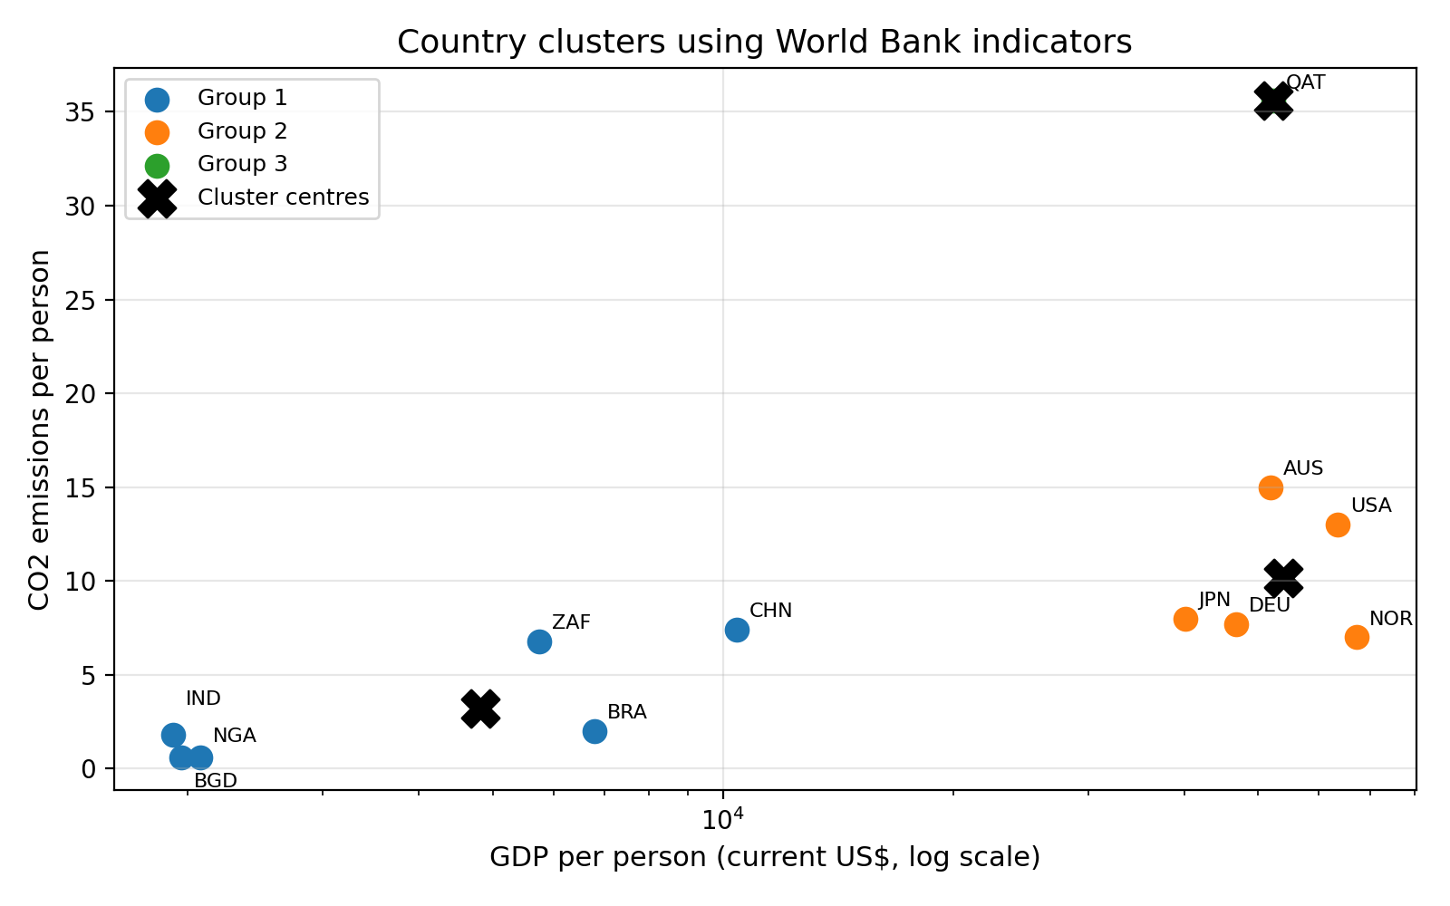
Figure 1. Country clusters and cluster centres. GDP is shown on a log scale to make both low-income and high-income countries visible.

3. Interpretation of the clusters
Bangladesh, India, China, Brazil, South Africa, and Nigeria make up Group 1. With the weakest economic output per resident, it stands apart. Lower carbon emissions go hand in hand here. Richer nations often burn through more power - this pattern shows why. Spending less on energy fits what you see in developing economies.
The second cluster includes the U.S., Germany, Japan, Norway, and Australia. People here earn more on average, also release more carbon dioxide each. Despite strong use of green power, Norway lands in this set along with rich nations. High income links closely to bigger emissions, even when clean energy plays a role.
Alone in Group 3 sits Qatar within this limited set of data. Its standout trait? A far greater amount of carbon dioxide released per resident compared to others picked here - yet almost no reliance on green power sources..

4. Fitting results
To fit the data, a straightforward quadratic approach was applied to China’s per-person CO₂ output. Not meant as an exact prediction, this kind of model stays rough around the edges. Its role here? Highlighting how shaping curves helps outline patterns, even when peeking ahead just a bit..
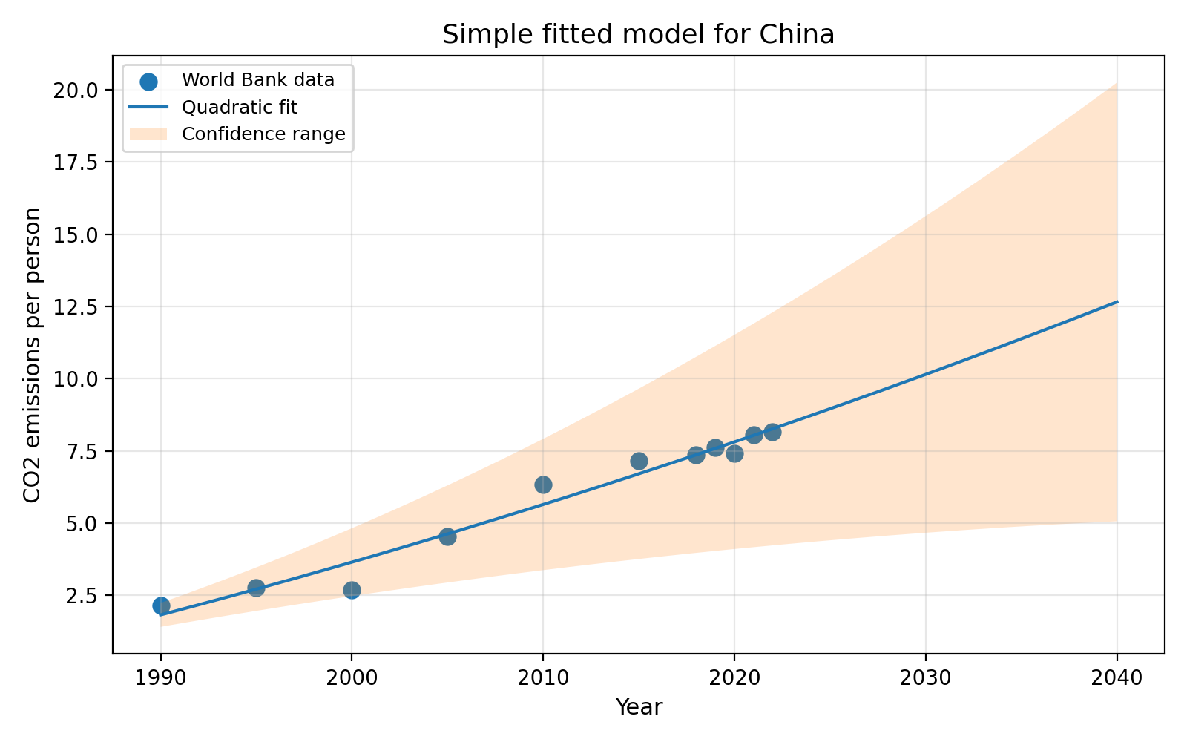
Figure 2. Quadratic fit for China's CO2 emissions per person with a confidence range.

5. Predictions and conclusion
Year | Prediction | Lower range | Upper range
2030 | 10.15 | 4.67 | 15.63
2040 | 12.66 | 5.06 | 20.25
Table 2. Predicted CO2 emissions per person for China.
One way to look at it: the model expects each person's share hits roughly 10.15 tonnes by 2030, then climbs toward 12.66 tonnes come 2040. A broad spread of possible outcomes shows up clearly - more so down near 2040. Care is needed when interpreting these numbers. Built on older carbon levels alone, the setup stays basic. Future shifts in rules, tools, or money flows sit outside its reach.
Looking at the big picture, clustering paints a clear enough story. From 1990, China saw its per-person emissions climb sharply - that much fits well with data trends. Some nations fall into a category where both income and carbon output stay low. Others join a cluster marked by higher wealth and bigger emissions. One country stands apart with sky-high pollution levels. Predictions hint at continued rise, yet confidence fades the farther ahead we look.
It's true - the work here suits someone just starting out. More places, longer time spans, plus extra measures would make it tougher in a good way. Still, every core piece got done: grouping after scaling, clusters shown raw, charts with pyplot, curves drawn, guesses made, and how sure we are marked clearly.

